Grand Canyon University

Assignment 2: Monitor and Semaphore

Evan Lee and Ryan Scott

CST-315: Operating Systems Lecture and Lab

Dr. Ricardo Citro

February 13, 2022

**Intro:**

In this assignment we implement a monitor and a semaphore in two different C++ programs that solve the producer and consumer problem. The producer and consumer problem contains a producer which will need to create something as long as the buffer is not full, while the consumer must consume what is created as long as the buffer is not empty. A monitor uses a class structure where there are private variables and functions the monitor can use to successfully solve the problem. There are multiple types of semaphores, but the main two are binary semaphores and counting semaphores.

**Monitor Code and Output:**

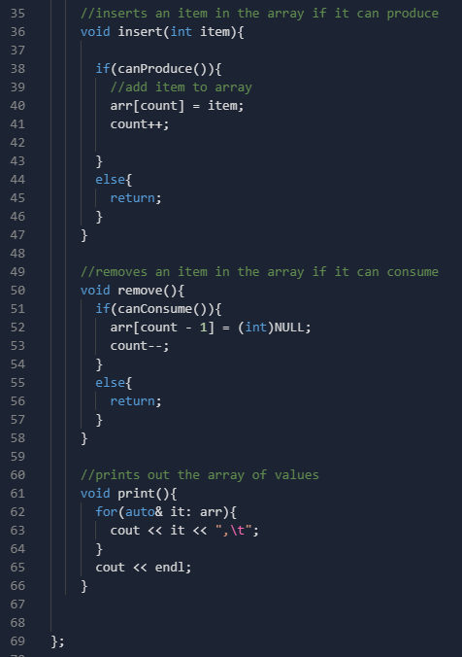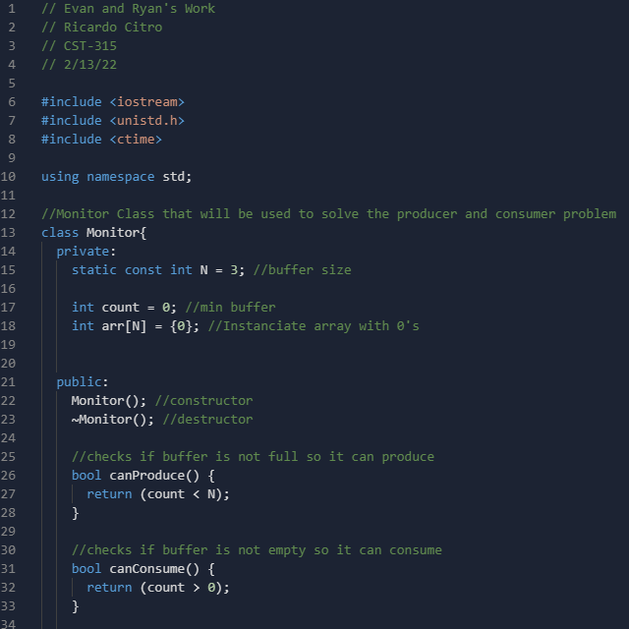

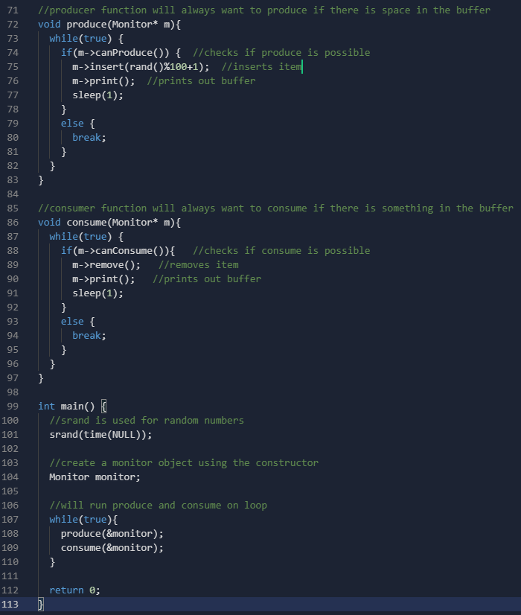 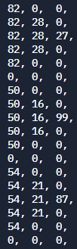

Output

**Semaphore Code and Output:**

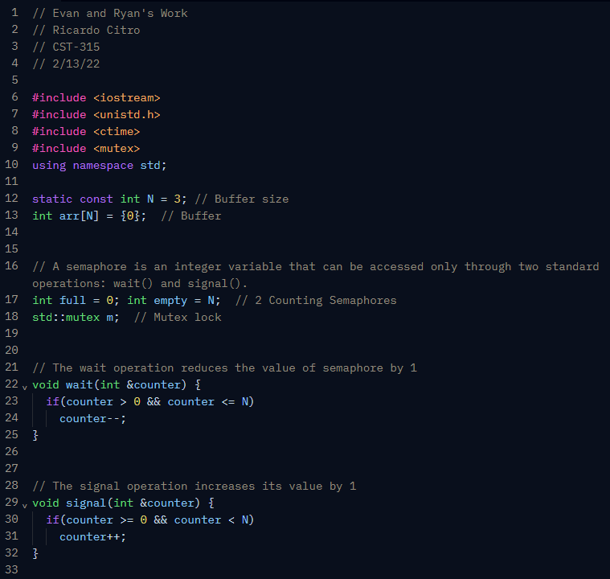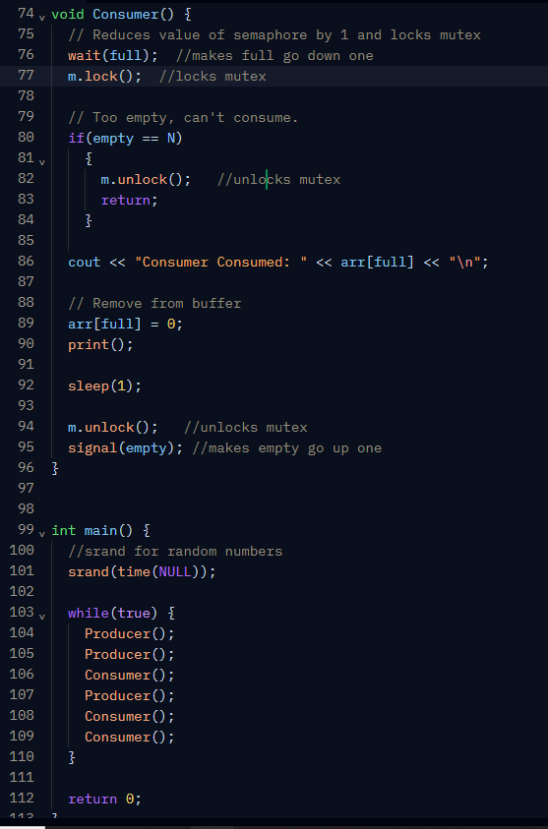

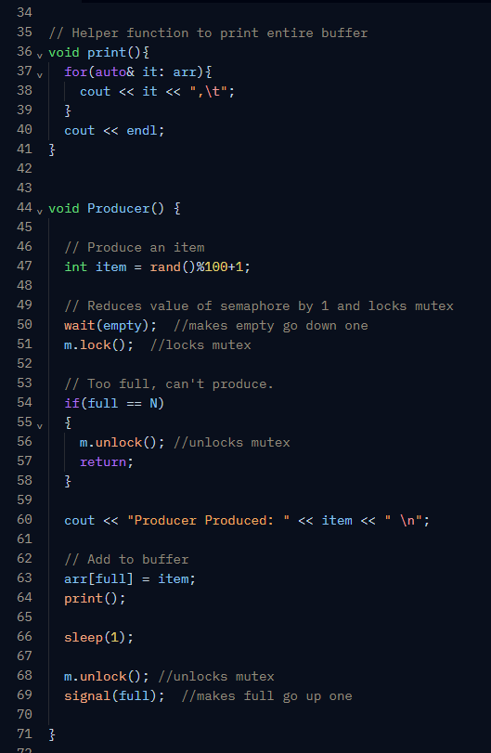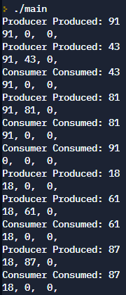

**Conclusion:**

Both instances of the semaphore and the monitor were successful in creating a working solution to the producer and consumer problem. The source code has been attached in the zipped folder along with a README file with instructions on how to download and execute the monitor and semaphore .cpp files.